How to use availability sets

In this tutorial, you learn how to increase the availability and reliability of your Virtual Machine solutions on Azure using a capability called Availability Sets. Availability sets ensure that the VMs you deploy on Azure are distributed across multiple isolated hardware nodes in a cluster. Doing this ensures that if a hardware or software failure within Azure happens, only a sub-set of your VMs are impacted and that your overall solution remains available and operational.

In this tutorial, you learn how to:

* Create an availability set
* Create a VM in an availability set
* Check available VM sizes
* Check Azure Advisor

This tutorial requires the Azure PowerShell module version 3.6 or later. Run Get-Module -ListAvailable AzureRM to find the version. If you need to upgrade, see [Install Azure PowerShell module](https://docs.microsoft.com/en-us/powershell/azure/install-azurerm-ps).

Availability set overview

An Availability Set is a logical grouping capability that you can use in Azure to ensure that the VM resources you place within it are isolated from each other when they are deployed within an Azure datacenter. Azure ensures that the VMs you place within an Availability Set run across multiple physical servers, compute racks, storage units, and network switches. If a hardware or Azure software failure occurs, only a subset of your VMs are impacted, and your overall application stays up and continues to be available to your customers. Availability Sets are an essential capability when you want to build reliable cloud solutions.

Let’s consider a typical VM-based solution where you might have 4 front-end web servers and use 2 back-end VMs that host a database. With Azure, you’d want to define two availability sets before you deploy your VMs: one availability set for the web tier and one availability set for the database tier. When you create a new VM you can then specify the availability set as a parameter to the az vm create command, and Azure automatically ensures that the VMs you create within the available set are isolated across multiple physical hardware resources. If the physical hardware that one of your Web Server or Database Server VMs is running on has a problem, you know that the other instances of your Web Server and Database VMs remain running because they are on different hardware.

Use Availability Sets when you want to deploy reliable VM-based solutions in Azure.

Create an availability set

You can create an availability set using [New-AzureRmAvailabilitySet](https://docs.microsoft.com/en-us/powershell/module/azurerm.compute/new-azurermavailabilityset). In this example, we set both the number of update and fault domains at *2* for the availability set named *myAvailabilitySet* in the *myResourceGroupAvailability* resource group.

Create a resource group.

Azure PowerShellCopyTry It

New-AzureRmResourceGroup -Name myResourceGroupAvailability -Location EastUS

Create a managed availability set using [New-AzureRmAvailabilitySet](https://docs.microsoft.com/en-us/powershell/module/azurerm.compute/new-azurermavailabilityset) with the **-sku aligned**parameter.

Azure PowerShellCopyTry It

New-AzureRmAvailabilitySet `

-Location EastUS `

-Name myAvailabilitySet `

-ResourceGroupName myResourceGroupAvailability `

-sku aligned `

-PlatformFaultDomainCount 2 `

-PlatformUpdateDomainCount 2

Create VMs inside an availability set

VMs must be created within the availability set to make sure they are correctly distributed across the hardware. You can't add an existing VM to an availability set after it is created.

The hardware in a location is divided in to multiple update domains and fault domains. An **update domain** is a group of VMs and underlying physical hardware that can be rebooted at the same time. VMs in the same **fault domain** share common storage as well as a common power source and network switch.

When you create a VM configuration using [New-AzureRMVMConfig](https://docs.microsoft.com/en-us/powershell/module/azurerm.compute/new-azurermvmconfig) you use the -AvailabilitySetId parameter to specify the ID of the availability set.

Create two VMs with [New-AzureRmVM](https://docs.microsoft.com/en-us/powershell/module/azurerm.compute/new-azurermvm) in the availability set.

Azure PowerShellCopyTry It

$availabilitySet = Get-AzureRmAvailabilitySet `

-ResourceGroupName myResourceGroupAvailability `

-Name myAvailabilitySet

$cred = Get-Credential -Message "Enter a username and password for the virtual machine."

$subnetConfig = New-AzureRmVirtualNetworkSubnetConfig `

-Name mySubnet `

-AddressPrefix 192.168.1.0/24

$vnet = New-AzureRmVirtualNetwork `

-ResourceGroupName myResourceGroupAvailability `

-Location EastUS `

-Name myVnet `

-AddressPrefix 192.168.0.0/16 `

-Subnet $subnetConfig

$nsgRuleRDP = New-AzureRmNetworkSecurityRuleConfig `

-Name myNetworkSecurityGroupRuleRDP `

-Protocol Tcp `

-Direction Inbound `

-Priority 1000 `

-SourceAddressPrefix * `

-SourcePortRange * `

-DestinationAddressPrefix * `

-DestinationPortRange 3389 `

-Access Allow

$nsg = New-AzureRmNetworkSecurityGroup `

-Location eastus `

-Name myNetworkSecurityGroup `

-ResourceGroupName myResourceGroupAvailability `

-SecurityRules $nsgRuleRDP

# Apply the network security group to a subnet

Set-AzureRmVirtualNetworkSubnetConfig `

-VirtualNetwork $vnet `

-Name mySubnet `

-NetworkSecurityGroup $nsg `

-AddressPrefix 192.168.1.0/24

# Update the virtual network

Set-AzureRmVirtualNetwork -VirtualNetwork $vnet

for ($i=1; $i -le 2; $i++)

{

$pip = New-AzureRmPublicIpAddress `

-ResourceGroupName myResourceGroupAvailability `

-Location EastUS `

-Name "mypublicdns$(Get-Random)" `

-AllocationMethod Static `

-IdleTimeoutInMinutes 4

$nic = New-AzureRmNetworkInterface `

-Name myNic$i `

-ResourceGroupName myResourceGroupAvailability `

-Location EastUS `

-SubnetId $vnet.Subnets[0].Id `

-PublicIpAddressId $pip.Id `

-NetworkSecurityGroupId $nsg.Id

# Here is where we specify the availability set

$vm = New-AzureRmVMConfig `

-VMName myVM$i `

-VMSize Standard_D1 `

-AvailabilitySetId $availabilitySet.Id

$vm = Set-AzureRmVMOperatingSystem `

-ComputerName myVM$i `

-Credential $cred `

-VM $vm `

-Windows `

-EnableAutoUpdate `

-ProvisionVMAgent

$vm = Set-AzureRmVMSourceImage `

-VM $vm `

-PublisherName MicrosoftWindowsServer `

-Offer WindowsServer `

-Skus 2016-Datacenter `

-Version latest

$vm = Set-AzureRmVMOSDisk `

-VM $vm `

-Name myOsDisk$i `

-DiskSizeInGB 128 `

-CreateOption FromImage `

-Caching ReadWrite

$vm = Add-AzureRmVMNetworkInterface -VM $vm -Id $nic.Id

New-AzureRmVM `

-ResourceGroupName myResourceGroupAvailability `

-Location EastUS `

-VM $vm

}

It takes a few minutes to create and configure both VMs. When finished, you'll have two virtual machines distributed across the underlying hardware.

If you look at the availability set in the portal by going to Resource Groups > myResourceGroupAvailability > myAvailabilitySet, you should see how the VMs are distributed across the 2 fault and update domains.

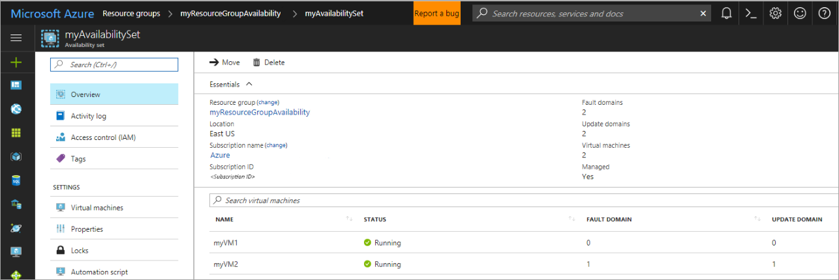

Check for available VM sizes

You can add more VMs to the availability set later, but you need to know what VM sizes are available on the hardware. Use [Get-AzureRMVMSize](https://docs.microsoft.com/en-us/powershell/module/azurerm.compute/get-azurermvmsize) to list all the available sizes on the hardware cluster for the availability set.

Azure PowerShellCopyTry It

Get-AzureRmVMSize `

-AvailabilitySetName myAvailabilitySet `

-ResourceGroupName myResourceGroupAvailability

Check Azure Advisor

You can also use Azure Advisor to get more information on ways to improve the availability of your VMs. Azure Advisor helps you follow best practices to optimize your Azure deployments. It analyzes your resource configuration and usage telemetry and then recommends solutions that can help you improve the cost effectiveness, performance, high availability, and security of your Azure resources.

Sign in to the [Azure portal](https://portal.azure.com/), select **More services**, and type **Advisor**. The Advisor dashboard displays personalized recommendations for the selected subscription. For more information, see [Get started with Azure Advisor](https://docs.microsoft.com/en-us/azure/advisor/advisor-get-started).